Town of Charleston, New York
Request for Proposal for a Comprehensive Plan
Proposals Due: May 15, 2024 - 12:00 PM

Map of Montgomery County, New York

窗体顶端
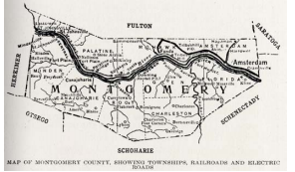

窗体底端

Town of Charleston, New York
Request for Proposal - Comprehensive Plan

Release Date: March 4, 2024

Proposal Due: May 15, 2024

The Town of Charleston, NY is requesting proposals from qualified planning consultants to assist in the development of the community’s first Comprehensive Plan to address current conditions and future sustainable growth within the township. The project is being funded by a 2023 Smart Growth Comprehensive Plan Contract T1002333 Grant from New York State Department of State. New York State Department of State Grant amount is $36,000 and Town of Charleston contribution amount is $4000 totaling $40,000

**** Please refer to Appendix A for information regarding the Town of Charleston, New York.

- Project Description

The Town of Charleston (Contractor) and its Comprehensive Plan Steering Committee (hereinafter CPSC) will prepare a Comprehensive Plan pursuant to General City Law 28 /Town Law 272-a / Village Law 7-722. This Comprehensive Plan will establish the objectives that our community wants to achieve and will guide future sustainable growth within the Town of Charleston. The selected planning consultant will work closely with the Steering Committee to develop the Comprehensive Plan through a public process that will engage a variety of community stake holders. Charleston’s Comprehensive Plan needs to respond to short term and long-term needs of the community, establish the objectives that Charleston wants to achieve, guide future sustainable growth, enhance quality of life and protect natural and cultural local resources.

The Comprehensive Plan must address the following general Smart Growth Principles, in addition to elements suggested by the New York State statutes:

- Promote mixed land uses in focus areas.
- Create an adequate range of housing opportunities and choice.
- Promote development and redevelopment where infrastructure is adequate and sustainable.
- Build on traits that make a distinctive and attractive community with a strong sense of place.
- Promote well-planned and well-placed public spaces.
- Promote sustainable compact neighborhoods.
- Increase mobility and circulation within jurisdictional lines and improve connectivity with areas outside jurisdictional lines.
- Promote sustainable mass transit that reduces the local levels of greenhouse gas emissions.
- Promote walk-able/bike-able neighborhood designs.
- Promote and integrate clean energy resources and related incentives.
- Improve green infrastructure and resident’s participation to this effort.
- Increase resiliency to extreme weather events.
- Encourage social diversity and integration.
- Expand planning and implementation efforts across jurisdictional lines, to increase effectiveness, sustainability and resiliency.
- Promote community and stakeholder collaboration in planning.

The Contractor will use the funding/grant for consultant services necessary for the coordination of the planning process and preparation of the Comprehensive Plan.

2. Project Attribution and Number of Copies

The Contractor must ensure that all materials printed, constructed, and/or produced acknowledge the contributions of the Department of State to the project. All final and public facing materials must include the Department of State logo and the following acknowledgment:

"This [document, report, map, etc.] was prepared with funding provided by the New York State Department of State Environmental Protection Fund."

The contributions of the Department of State must also be acknowledged in community press releases and other notices issued for the project, including web site postings and other forms of digital distribution. Project press releases and other notices shall be submitted to the Department of State for review and approval prior to release, to ensure appropriate attribution.

The Contractor must submit to the Department of State all required products, clearly labeled with the NYS Comptroller's contract number as indicated on the Face Page of this Request for Proposal Contract and where applicable and related task number from this Work Plan.

Unless otherwise specified in the Work Plan tasks, the Contractor shall submit products in the following formats:

- Draft products: one digital copy of each product must be submitted in Microsoft Word and Adobe® Acrobat® Portable Document Format (PDF), created using 300 dpi scanning resolution.
- Final products: one electronic copy of each product must be submitted in Microsoft Word, PDF (20 MB maximum, per PDF), created using 300 dpi scanning resolution. In addition, one paper copy of each final product (including reports, designs, maps, drawings, and plans) must be submitted, upon request.
- Electronic data for all Geographic Information System-based mapping products and associated spatial data must be submitted in either ArcGIS format, or similar product acceptable to the Department, and comply with the requirements for Contract GIS Products. Formal metadata must be provided with all digital GIS data which includes, at minimum, a file summary/abstract, intended use, data, source data, and author information.
- Electronic data for all designs, drawings, and plans must be submitted in the original software in which they were created (such as CAD format or other similar product acceptable to the Department of State), as well as in JPG format.
- Photographs and images must be submitted in JPG format with a minimum resolution of 300 dpi, must be dated and captioned with the location and a brief description of the activity being documented, and include any associated metadata (including the photo’s GPS location where available).

3. Project Components

Task 1: Project Initiation Meeting

The Contractor, the Department, and any partners responsible for managing the project, shall hold an initial meeting to review and agree upon the project scope and schedule, project requirements, budget, roles and responsibilities, the selection process for procuring consultants, State Environmental Quality Review Act (SEQRA) compliance requirements, MWBE requirements, the number of public meetings and techniques for public involvement proposed for the project, and any other information which would assist in project completion. In addition, the composition and role of the CPSC shall be discussed during the project initiation meeting. The Contractor, or a designated project partner, shall prepare and distribute to all project partners a brief meeting summary clearly indicating the agreements reached at the meeting. Work on subsequent tasks shall not proceed prior to Department review of the proposed approach as outlined in the meeting summary.

Products: Project initiation meeting held with appropriate parties. Written meeting summary outlining agreements reached.

Task 2: Procurement of Consultant (if applicable)

Prepare a Request for Proposal (RFP) or similar instrument (if applicable) including a complete project description with site conditions, expected final results, a schedule for completion, MWBE requirements, and criteria for selecting a preferred proposal. Consultant services requested shall include all applicable tasks, activities and responsibilities outlined in the "Project Components" section of this work program.

The Contractor must actively solicit bids for contracts and subcontracts from qualified State certified MWBEs which can be identified using the NYS Directory of Certified Firms (https://ny.newnycontracts.com). The Contractor must retain records of the procurement process including direct solicitation to MWBEs, results, and any actions that its subcontractors have taken toward meeting MWBE contract participation goals. To demonstrate good faith efforts to achieve MWBE contract goals the following should be retained:

- Evidence of outreach to MWBEs: mail, email, phone calls and follow-up.
- Written responses by MWBEs to the grantee/vendor’s outreach.

Task 3: Comprehensive Plan Steering Committee Meetings

The CPSC will meet on a regular basis during the planning process to advance the preparation, review, and approval of the Comprehensive Plan, and to organize and conduct community participation events.

During the first meeting, the CPSC will review project requirements and roles and responsibilities, transfer necessary information to the team of consultants (if applicable), and identify new information needs and next steps. The CPSC or the consultant (if applicable) will prepare and distribute a brief meeting summary clearly indicating the understandings reached at the meeting.

All subsequent meetings will advance the preparation of the Comprehensive Plan and assess the evolution of the project, the new information needed, changes in roles and responsibilities, and next steps.

Work on subsequent tasks shall not proceed prior to Department of State review.

Products: Meetings held with appropriate parties. Written meeting summaries outlining what has been discussed and understandings reached and identifying the participants to the meeting.

Task 4: Community Participation Plan

Prepare a Community Participation Plan that describes the public outreach and participation efforts that will be conducted during the development of the Comprehensive Plan, pursuant to the local and State statutes. At a minimum, the Community Participation Plan shall include (in-person or virtual) interviews with local and regional stakeholders, a community survey, a public information meeting, one or more public workshops, one or more public hearings, and a web-page with links to announcements, presentations and documents prepared during the planning process.

The Community Participation Plan shall identify key individuals, organizations, and entities to be involved, and shall identify roles and responsibilities in coordinating the entire outreach process, logistics, and the proposed schedule of the proposed public outreach and participation efforts.

All public outreach and participation efforts will be publicized in the community through press releases, announcements, individual mailings, and any other appropriate means. Public access must be provided to each public meeting or workshop. Outreach efforts should encourage participation from populations who are frequently underrepresented in this process, including immigrants, refugees, and minorities.

Meeting(s) and public engagement(s) should be scheduled at times that are convenient to underrepresented communities (e.g., at night or on weekends instead of during the day) and at locations that are ADA accessible. Meetings shall be advertised with generous advance notice to garner maximum publicity, awareness, and participation.

A summary of each public outreach and participation efforts will be made available to the public in written form and through other appropriate means, such as websites.

Products: Draft and final Community Participation Plan.

Task 5: Community Survey and Stakeholder Interviews

Develop a relevant and realistic community survey about current local conditions and issues. The survey should be made available to the public as hard copy and online. In addition, identify a set of topics that shall be discussed with stakeholders to obtain additional relevant information and elicit stakeholder reactions and suggestions. Following the completion of the survey, develop a summary of results and analysis.

Products: Draft final Community Survey. Draft and final list of topics to be discussed during the stakeholder interviews. Summary of survey and interviews responses and analysis.

Task 6: Review Local and Regional Planning Efforts and Ongoing Initiatives

Identify and review existing local and regional planning documents and ongoing initiatives. This review process will also include consultation with community leaders and with neighboring communities, if applicable, to identify common issues and assess if Smart Growth principals are the basis for addressing those issues.

The CPSC and the consultant(s), if applicable, shall develop a written findings report describing and assessing existing planning documents and the issues and opportunities identified by community leaders.

Products: Written findings report.

Task 7: Community Profile

Draft a Community Profile consisting of an inventory and analysis of existing conditions, including narrative, maps, and relevant data. The inventory will be used to assist in the identification of local issues and potential opportunities. The analysis of the local conditions and issues will be conducted from a Smart Growth perspective and identify potential solutions to existing issues and potential opportunities. A chart of smart growth principles will be provided to be included in the Comprehensive Plan which will summarize the opportunities and challenges to addressing each principle. The inventory and analysis of existing conditions may include the following, at a minimum:

- History of the municipal jurisdiction and boundaries.
- Description of previous comprehensive plan development and adoption processes.
- Demographic characteristics (population and growth trends, age distribution, average household size, ethnic composition, average household income, social diversity and integration, demographic trends).
- Local and regional economic characteristics: unemployment rates and trends, work force characterization, dominant business sector type, major employers and industries, sales tax information, property tax rates, economic trends and jobs range.
- Housing characteristics (the age, type, and condition of structures, type of occupancy - renters versus owners, vacancy rates and trends in the community and length of residency - percentage of residents five years in home, the extent and availability of low-income housing throughout the community and in identified neighborhoods, assessment of housing opportunities and choices, housing trends and access to jobs).
- Local and regional economies and development trends (including housing, commercial, industrial and agricultural development).
- Land use and smart growth focus areas.
- Agricultural and forest lands, uses, and districts.
- Hazardous Mitigation.
- Infrastructure and public utilities (i.e., drinking water supply, sewage disposal, solid waste disposal, storm water management and green infrastructure, communications, gas and electricity) extent, capacity, age, and maintenance.
- Transportation systems, local levels of greenhouse gas emissions, levels of mobility and circulation, walk-able/bike-able neighborhoods, connectivity with areas outside jurisdictional lines, distance to jobs.
- Natural resources and climate (air quality, watercourses, wetlands, floodplains, aquifers, forests/tree cover, steep slopes, soil types, and rare plant and animal habitats, precipitations, winds, temperatures, etc.).
- Extreme weather events, flooding, erosion hazards, and local resiliency.
- Health and emergency services and facilities.
- Parks and public spaces, recreation facilities, range of passive and active recreation, capacity and maintenance, accessibility etc.
- Historic, cultural, and scenic resources.
- Waterfront resources and public access.
- Zoning and other relevant local development controls.
- Fiscal resources.

The draft Community Profile shall be submitted to the Department for review before being used to design workshop activities and prepare materials needed to conduct community visioning workshops or to draft the Comprehensive Plan.

Products: Community Profile report, including a comprehensive inventory and analysis in the form of relevant data, narrative, maps, and graphics.

Task 8: Community Visioning Workshops

Conduct at least two public workshops that will inform the public about the findings of the planning process conducted up to this point, present a clear assessment of how Smart Growth policies are integrated in the municipality’s planning efforts, governmental decisions, and ongoing initiatives, and will solicit public input on existing resources, community character, and future growth.

The workshops are also intended to identify Smart Growth solutions to current issues and future growth. Each workshop shall be advertised with generous advance notice to garner maximum publicity, awareness, and participation. The site of the workshops must be accessible to the public.

Products: Published workshops announcements and fliers. Materials prepared for each public workshop. Workshops held.

Task 9: Draft Comprehensive Plan

Assemble the draft Comprehensive Plan that addresses each of the Smart Growth policies and establishes a long-term strategy for future growth and protection of resources, and may include the following topics commensurate with the community’s needs and vision for future actions:

- Goals, objectives, principles, policies, and standards upon which proposals for the immediate and long-range enhancement, growth, and development of the community.
- Consideration of regional needs and the official plans of other government units and agencies within the region.
- The existing and proposed location and intensity of land uses.
- Consideration and recommendations for the protection of agricultural and forest lands, historic and cultural resources, natural resources, and sensitive environmental areas.
- Consideration of population, demographic and socioeconomic trends and future projections.
- Location and types of transportation facilities that reduce the local levels of greenhouse gas emissions.
- Existing and proposed general location of public and private utilities and infrastructure, including clean energy generation.
- Existing housing resources and future housing needs, including affordable housing.
- The present and potential future general location of educational and cultural facilities, historic sites, health facilities, and facilities for emergency services.
- Existing and proposed recreation facilities and parkland.
- The present and potential future general location of commercial and industrial facilities.
- Specific policies and strategies for improving the local economy in coordination with other plan topics.
- Proposed measures, programs, devices, and instruments to implement the goals and objectives of the various topics within the Comprehensive Plan.
- All or part of applicable plans of other public agencies.
- Any and all other items which are consistent with the orderly growth and development of the community.

A detailed strategy implementing the community’s policies, concepts, projects, and programs shall be identified in the plan. This includes phased implementation approach (short, mid, and long‐term), as well as anticipated costs, and priorities.

Submit the draft Comprehensive Plan to the Department for review and approval and incorporate the Department's comments in the final plan.

Products: Draft Comprehensive Plan, including relevant data, narrative, maps, and graphics.

Task 10: Review by the Local Municipal Board

Submit the draft Comprehensive Plan to the local municipal board for review, comments, and recommendations. The comments received from the local municipal board shall be addressed before the initiation of the SEQRA compliance process.

The comments and recommendations prepared by the local governing board/local legislature shall be addressed and incorporated into the final plan and prior to making the draft available for public review.

Products: Comments and recommendations received from the local municipal board submitted to the Department of State.

Task 11: Environmental Quality Review

Prepare materials necessary for compliance with the State Environmental Quality Review Act (SEQRA). The adoption of a new or amended Comprehensive Plan is classified as a Type I action, pursuant to the State Environmental Quality Review Act (SEQRA) and 6 NYCRR Part 617. The CPSC or the consultant(s) shall comply with SEQRA requirements and, if appropriate, prepare the Generic Environmental Impact Statement (EIS) to provide a review of land use actions proposed in the Comprehensive Plan. The local municipal board shall declare to be the Lead Agency for the action of adopting the new or amended Comprehensive Plan.

The Department recommends the following resource:

Department of Environmental Conservation’s SEQR Handbook available at https://extapps.dec.ny.gov/docs/permits_ej_operations_pdf/seqrhand book.pdf for guidance on the use of SEQR in the planning process.

Copies of all SEQR documents shall be submitted to the Department.

Products: SEQRA documents

Task 12: County Planning Board Review

Submit the draft Comprehensive Plan to the County Planning Board for review and recommendations pursuant to Section 239-m of the New York State General Municipal Law. This will be submitted by the Town of Charleston.

Comments received from the County Planning Board shall be addressed in the final version of the Comprehensive Plan that will be locally adopted. Comments received from the County Planning Board shall be submitted to Department of State.

Products: Comments and recommendations prepared by the County Planning Board.

Task 13: Final Comprehensive Plan

Address all comments and recommendations received from the public and involved local, regional and State agencies and incorporate into the Final Comprehensive Plan and schedule a public hearing and the local adoption of the plan.

The Final Comprehensive Plan and the date of the public hearing and local adoption of the plan shall be submitted to Department.

Products: Final Comprehensive Plan ready for local adoption.

Task 14: Public Hearing and Local Adoption

Conduct a public hearing prior to adoption of the Comprehensive Plan. Notice of the public hearing shall be published in a newspaper of general circulation in the community at least ten calendar days in advance of the hearing. The proposed Comprehensive Plan shall be made available for public review during the announced period at the Town of Charleston Office and public library. They shall also be posted on the municipal website. The public hearings may also be publicized in the community through press releases, announcements, individual mailings, and any other appropriate means.

Copies of the public hearing minutes and the local adoption resolution shall be submitted to the Department of State.

Products: Minutes from the public hearings and record of decision submitted to Department.

Task 15: MWBE Reporting

Comply with MWBE Reporting Requirements by completing the following actions:

- Submit Form C - Workforce Employment Utilization to report the actual work force utilized for this contract broken down by specified categories (every March 31, June 30, September 30 and December 31).
- Submit Form D - MWBE Utilization Plan to indicate any state-certified MWBE firms selected to work on this contract. Form D must be updated and submitted to the Department of State whenever changes to the selected MWBE firms occur (addition or removal).
- Record payments to MWBE subcontractors using DOS funds through the New York State Contract System (NYSCS).

Technical assistance for use of the NYSCS system can be obtained through the NYSCS website at https://ny.newnycontracts.com by clicking on the “Contact Us & Support” link.

Products: Ongoing reporting through NYSCS during the life of the contract. Form C submitted on a quarterly basis and Form D submitted as necessary.

Task 16: Project Status Reports

Submit project status reports semi-annually (every June 30 and December 31) on the form provided, including a description of the work accomplished, the status of all tasks in this work plan, schedule of completion of remaining tasks, and an explanation of any problems encountered.

Products: Completed project status reports submitted during the life of the contract to be submitted by the Town of Charleston Comprehensive Plan Steering Committee

Task 17: Final Project Summary Report and Measurable Results

Submit the Final Project Summary Report and Measurable Results electronically to: Daniel.Lapin@dos.ny.gov

Products: Final Project Summary Report and Measurable Results submitted to the Department of State by the Town of Charleston CPSC.

4. Project Responsibilities

The Contractor shall administer the grant, execute a contract with the Department of State, and ensure the completion of work in accordance with the approved Work Plan and budget.

The Contractor:

- Will be responsible for conducting all project work in conformance with the Work Plan included in the executed contract with the Department.
- Will be responsible for all project activities including drafting request for proposals and managing subcontracts with consultants and sub-consultants.
- Will certify to the Department that the procurement record for project consultants and subcontractors complies with the applicable provisions of General Municipal Law.
- Will receive approval from the Department for any and all consultant subcontracts before beginning project work.
- Will be responsible for submission of all products and payment requests.
- Will be responsible for coordinating participation and soliciting comments from local government personnel, project volunteers, and the public.
- Will be responsible for ensuring that all public engagement communications and opportunities are made accessible to underrepresented communities (e.g., meeting locations, meeting materials, meeting notices, plan documents).
- Will keep the Department informed of all important meetings for the duration of this contract.
- Will receive approval from the Department before purchase of any equipment.
- Will secure all necessary permits and perform all required environmental reviews.
- Will ensure that all materials printed, constructed, and/or produced acknowledge the contributions of the Department to the project.
- Will ensure that all products prepared as a part of this contract shall include the NYS Comptroller's contract # as indicated on the Face Page of this contract.
- Will ensure the project objectives are being achieved.
- Will ensure that comments received from the Department and the project advisory committee, or other advisory group, are satisfactorily responded to and reflected in subsequent work.
- Will recognize that payments made to consultants or subcontractors covering work carried out or products produced prior to receiving approval from the Department will not be reimbursed unless and until the Department finds the work or products to be acceptable.

The Department of State:

- Will review and approve or disapprove of subcontracts between the Contractor and consultant(s) and any other subcontractor(s).
- Will participate in project initiation meeting and attend meetings that are important to the project.
- Will review all draft and final products and provide comments as necessary to meet the objectives.
- Must approve or disapprove any and all design, site plan, and preconstruction documents. Department approval must be obtained before construction may begin.

SUBMISSION OF PROPOSALS
Interested respondents must submit three (3) paper copies and one (1) electronic version (USB flash drive) of their proposal no later than 12:00 P.M. on May 15, 2024. Proposals should be submitted to:

Town of Charleston – Town Hall
480 Corbin Hill Road
Charleston, NY 12066
Attention: Supervisor Robert Sullivan
Email charlestonsupervisor1@gmail.com
If you have further questions contact Jim Capron at 1-518-698-3502.
Proposals received after the scheduled time and date will not be accepted. Facsimile and email proposals will not be accepted.
PROPOSAL CONTENT AND CONDITIONS
Each proposer must submit a complete proposal which addresses each component of the RFP.
- A cover letter expressing the firm’s interest in working with the Town of Charleston and Charleston CPSC.
- A description of the general approach to be taken to complete the project, an explanation of any variances to the proposed project scope of work as outlined in the RFP, and any insight gained as a result of developing the proposal.
- A full description of how the Scope of Work will be completed along with a schedule detailing when tasks will be completed, and products/deliverables resulting from each task.
- Budget and expense information which details all costs including:
- Personnel expenses which state the name/title of everyone assigned to the project, hourly rates and the number of estimated hours the individual will be working on the project. Percentage of availability project members have to work project. The same information should be submitted in detail for subcontractors.
- Administrative costs for travel, postage, photocopying, telephone, printing, and other related expenses must be detailed.
- Estimates of expense for each of the tasks with assumptions.
- A description and /or resume for each staff member or sub-consultant who will be involved with this project and their roles / responsibilities.
- A representative work sample comparable to the work being requested. Examples of previous comprehensive plans worked on which are similar to the Town of Charleston’s.
- Demonstrated success on projects of similar scope and nature. Please include brief project descriptions for each and project contact name / phone number for reference.
- A description of the respondents’ efforts to comply with New York State’s MBE/WBE goals.
Proposal items 2-5 should be limited to 15 pages. Resumes, professional qualifications and work samples are not included in this total.
The electronic version must be in PDF format, divided into two (2) or more PDFs as described below:
- First PDF- Project letter of interest, required proposal components, resumes, summary of previous relevant work, proposed budget and schedule.
- Second PDF- Examples of previous relevant work.
Conditions Governing Proposals
Only those proposals which contain complete information and are responsive to the RFP will be considered. Proprietary or patented information which may be included in the proposal must be clearly identified and brought to the committee’s attention.
The Town of Charleston, New York reserves the following rights:
- To accept or reject any or all proposals.
- To waive or modify minor irregularities in proposals received.
- To negotiate with proposers, within proposal requirements, to best serve the interests of the community and Department of State.
- To amend specifications after their release, with due notice given to all bidders to modify their proposals to reflect changed specifications.
- To consider every offer as firm and not revocable for a period of sixty (60) days unless withdrawn in writing or unless otherwise specified in the solicitation.
- To award a contract for any and all parts of a proposal including award of specific project components to individual proposer team members and to negotiate with the successful bidders.
- By submitting a proposal, the proposer agrees that it will not make any claim for or have any right to damages because of any lack of information or misinterpretation of the information provided in this RFP.
- The Town of Charleston, New York will not utilize any of the materials submitted in the RFP process included in unsuccessful proposals without permission.
The New York State Department of State must approve all consultants and subcontractors.
The consultant must comply with all provisions of the contract between the New York State Department of State and the Town of Charleston, New York including all appendices. A copy of the contract is available upon request.
NEW YORK STATE MWBE PARTICIPATION REQUIREMENTS
Pursuant to New York State Executive Law Article 15-A, the State recognizes its obligation under the law to promote opportunities for maximum feasible participation of certified minority and women-owned business enterprises and the employment of minority group members and women in the performance of State contracts. For the purposes of this project, the NYS Department of State has established an MWBE participation requirement of 30% of the total State grant contract value. The selected proposer, if not certified MWBE, must actively solicit for bids for contracts and subcontracts from qualified State certified MWBEs which can be identified using the NYS Directory of Certified Firms (https://ny.newnycontracts.com/). The Contractor must retain records of the procurement process including direct solicitation to MWBEs; results; and any actions that its subcontractors have taken toward meeting MWBE contract participation goals. To demonstrate good faith efforts to achieve MWBE contract goals the following should be retained:
- Evidence of outreach to MWBEs: mail, email, phone calls and follow-up.
- Written responses by MWBEs to the grantee/vendor’s outreach.
- Copies of search(es) of the directory and advertisements for participation by MWBEs in appropriate general circulation, trade, and minority or women-oriented publications.
- Attendance at any pre-bid, pre-award, or other meetings, if any, scheduled by the grantee with MWBEs including dates and location.
- Description of how the scope of work maximizes opportunities for MWBE participation.
- Description of how non-MWBE subcontractors have engaged MWBEs to undertake part of the project’s work or to procure equipment/ materials/supplies.
INQUIRIES
All inquiries regarding the RFP should be made in writing and sent either regular mail or email (preferred) and must cite the RFP section in questions. Answers to substantive questions will be provided to all proposers. Inquiries should be directed to:
Jim Capron
Town of Charleston, New York
Comprehensive Plan Steering Committee
782 Esperance Road,
Esperance New York,12066
Cell Phone: 1-518-698-3502
E-mail: jcapron@yahoo.com
PROPOSER INTERVIEWS
The Town of Charleston will conduct interviews with the two to three (2-3) highest scoring proposals, as needed. The intent of the interview process will be to provide the Town and the Comprehensive Plan Steering Committee with an opportunity to obtain an understanding of:
- The extent of the firm’s depth of knowledge of the subject matter of the RFP, overall project understanding, and insight into local conditions.
- Whether the methods and resources that will be used by the firm performing the services to achieve the project goals and objectives are appropriate and cost effective.
- The firm’s ability to draw together specialists and professionals with the necessary skills and experience to contribute to the overall project.
- To allow proposers to further define the primary features and benefits of their proposal.
- To evaluate the communication and public presentation skills of the proposers.
LIABILITY
The Town of Charleston and the Steering Committee are not liable for any cost incurred by any individual or firm for work performed to prepare its proposal or for any travel and/or other expenses incurred in the preparation and/or submission of its proposal. Further, the Town of Charleston is not liable for any costs incurred prior to approval of the contract.
EVALUATION PROCESS
The Town of Charleston Comprehensive Plan Steering Committee, and representatives from the NYS Department of State will review submitted proposals with reference to the qualifications and criteria as detailed in this RFP. The intent is to select the planning consultant firm having the technical capability and necessary experience to perform the services as outlined in this RFP within the time frame required. Please note that the total grant funding award has not been presented in this RFP as the Town of Charleston will select a consultant through a qualifications-based selection process. The selection of a consultant will be made without regard to race, color, age, religion, national origin, or political affiliation.
SELECTION CRITERIA
The selection of a consultant for this effort will be based on the following criteria:
- Technical Proposal: Proposals will be evaluated based on their quality and clarity; creativity and thoroughness in addressing the Scope of Work; demonstration of overall project understanding and insight into local conditions and potential issues. Proposal must include a plan outlining how each Task in the Scope of Work will be addressed. (25 pts)
- Relevant Experience: Proposer must provide a list of projects similar in scope and nature completed in the last 5 years. Proposer should demonstrate experience with New York State-based land use and planning, local laws, and regulations. Proposals will also be evaluated based on quality of representative work sample provided. (20 pts)
- Implementation Schedule: Proposals will be evaluated based on ability and capacity to complete project by 03/31/2026. Proposal must include an implementation schedule that lists all milestones for the development and implementation of project deliverables. (10 pts)
- Cost Proposal: A cost proposal outline organized to follow the outline of Scope of Work, with detail of cost assigned for the task/action, including personnel costs and reimbursable expenses. (15 pts)
- Team Composition and Resumes: Evaluation will be based upon the experience of the consultant personnel working together as a team to complete comparable projects. The Proposer must provide a list of all person(s) who will be assigned work pursuant to this RFP (including subcontractors) and resumes showing qualifications and relevant experience. Proposer must designate an individual as the Project Manager who will be directly responsible for all activities of the organization relevant to this RFP and provide their resume and relevant experience. The designated Project Manager must have managed the implementation of at least one other project of similar scope and nature, a description of which must be submitted with the Project Manager resume. (20 pts)
- Presentation/Communication Skills: The proposer will be evaluated based on their knowledge of the subject material, their overall understanding of the proposed project, their ability to relay the message in a clear, concise, and timely fashion and their ability to field questions posed to them from the Town and Comprehensive Plan Steering Committee members. (10 pts)
NOTIFICATION OF AWARD
The Town of Charleston will notify the successful bidder by phone and/or email, followed by written confirmation. Each bidder whose proposal is not accepted will be notified in writing. The Town of Charleston will authorize the award of a contract to the successful proposer based upon the evaluations and recommendations of the Steering Committee. In the event that a contract cannot be finalized within thirty (30) days of the award, the Steering Committee reserves the right to enter negotiations with the consultant which received the second highest evaluation.
The New York State Department of State must approve all consultants and subcontractors.

Appendix A
Town of Charleston Information
Town of Charleston
Welcome to the Town of Charleston, New York. We hope you find all the necessary information below to inform you about our Rural Town.
Nestled in the southeastern corner of Montgomery County, New York, Charleston is a community of approximately 1,200 residents. We are a rural area situated 30 minutes from the cities of Amsterdam and Schenectady and 45 minutes from the State capital of Albany, NY. The nearby interstate systems of I-88 and I-90 makes getting to the larger cities very easy.
The Town of Charleston includes the hamlets of Burtonville, Charleston Four Corners, Oak Ridge and Rockwell Corners. The Town of Charleston is on the south border of Montgomery county and is the only town in the county not bordering the Mohawk River.
Charleston is fortunate to have in its boundaries over 4,000 acres of state and county forests dedicated to providing great hunting, fishing, hiking, x-country skiing, horseback riding and snowmobiling.
Our town board and employees work very hard to provide a well-maintained highway system to insure safe travel for our school buses and residents.
Property values have remained strong despite lower valuations elsewhere in the State. This is due in part to the higher elevations, views, services offered and friendly atmosphere experienced by those who visit and decide to live here.
With the strong growth of industry at Global Foundries in nearby Malta, and the Nano Tech Centers in Albany, Charleston provides a quiet setting and close proximity to living near these technology hubs.
On behalf of all the employees, residents and town board members, we encourage you to make an effort to come visit us. After all, we think our town is the next best thing to perfection.

History
Parts of Charleston were in Corry’s Patent (1637), Stone Heap Patent (1770), and Thomas Machin’s Patent (1787). Settlers began arriving before the American Revolution.
The Town of Charleston was formed by a division of the original “Town of Mohawk” in 1793. This division, which also created the Town of Florida, terminated Mohawk as a town until another town with that name (Mohawk) was created in 1837. Charleston was reduced in size in 1823, when the Towns of Glen and Root (in part) were established.

Charleston Historical Society
The Charleston Historical Society was founded in 1978 by Edythe J. Meserand and is located in the Baptist Church on Polin Road, just off State Rt 30A.
The building was added to the National Register of Historic Places in 1974.
For further information on the history of Charleston and the Charleston Historical Society contact Lorraine Whiting, Town of Charleston Historian, at 518-922-5867.
Additional Information:
During 1999 thru 2000 a comprehensive plan committee was formed in the Town of Charleston. This group developed a comprehensive plan which was never approved by the Town of Charleston’s Board, Charleston town citizens, Montgomery County or NY State. Today we still have no understanding why this plan was never accepted. We will be providing a copy of the plan this committee developed with the RFP which should help reduce some work.
Recently a Hazardous Mitigation Plan has been developed with Taigh & Bond for the Town of Charleston and will be included with this package.

Photographs and Information

Charleston is nestled in a beautiful NY State Forest where many sporting activities are permitted.
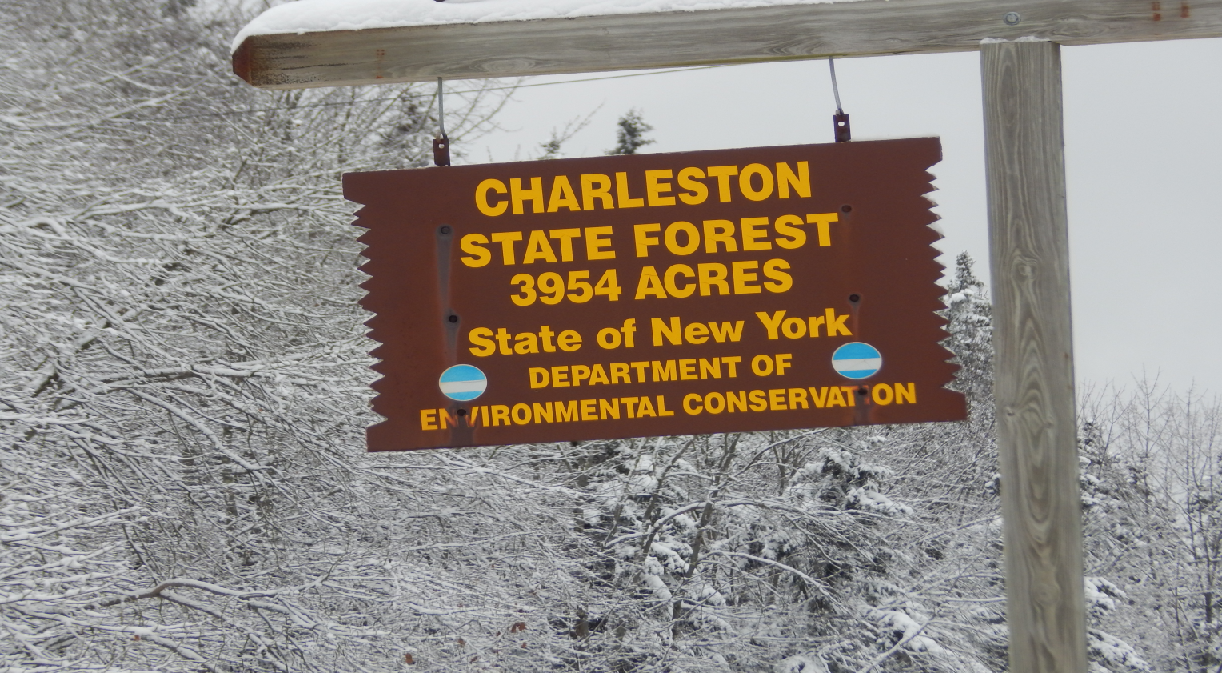

Charleston also has a spectacular county forest where hiking, hunting, fishing, cross country skiing are permitted. We also have the first disc golf course in Montgomery County.
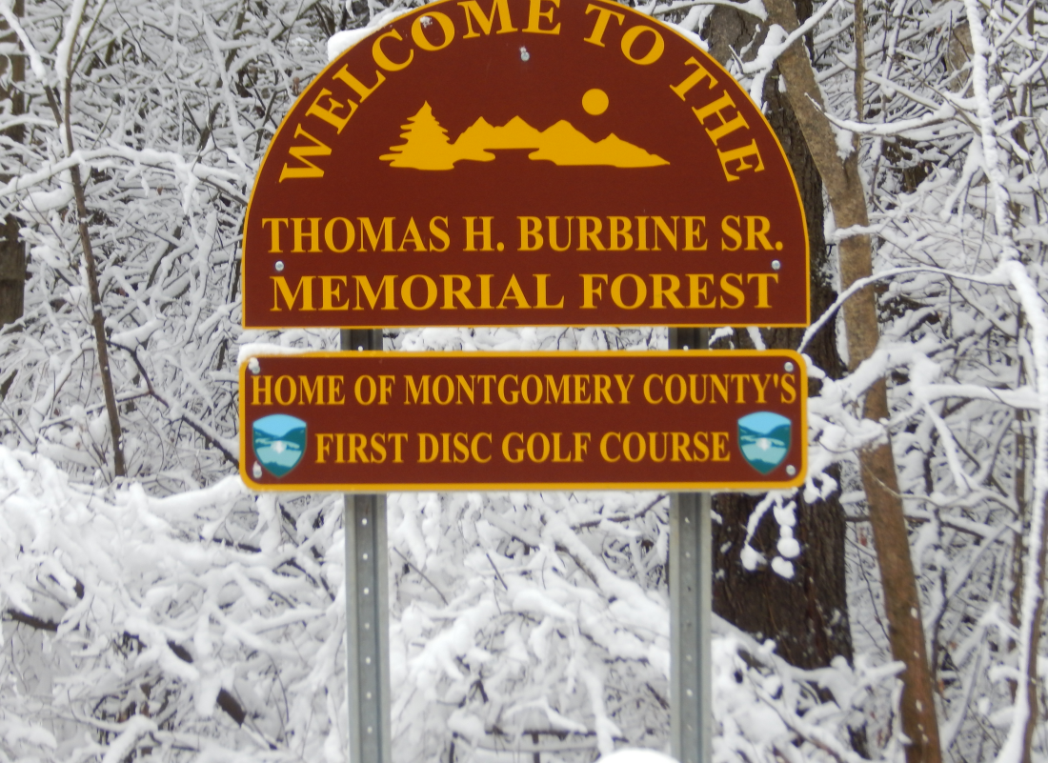
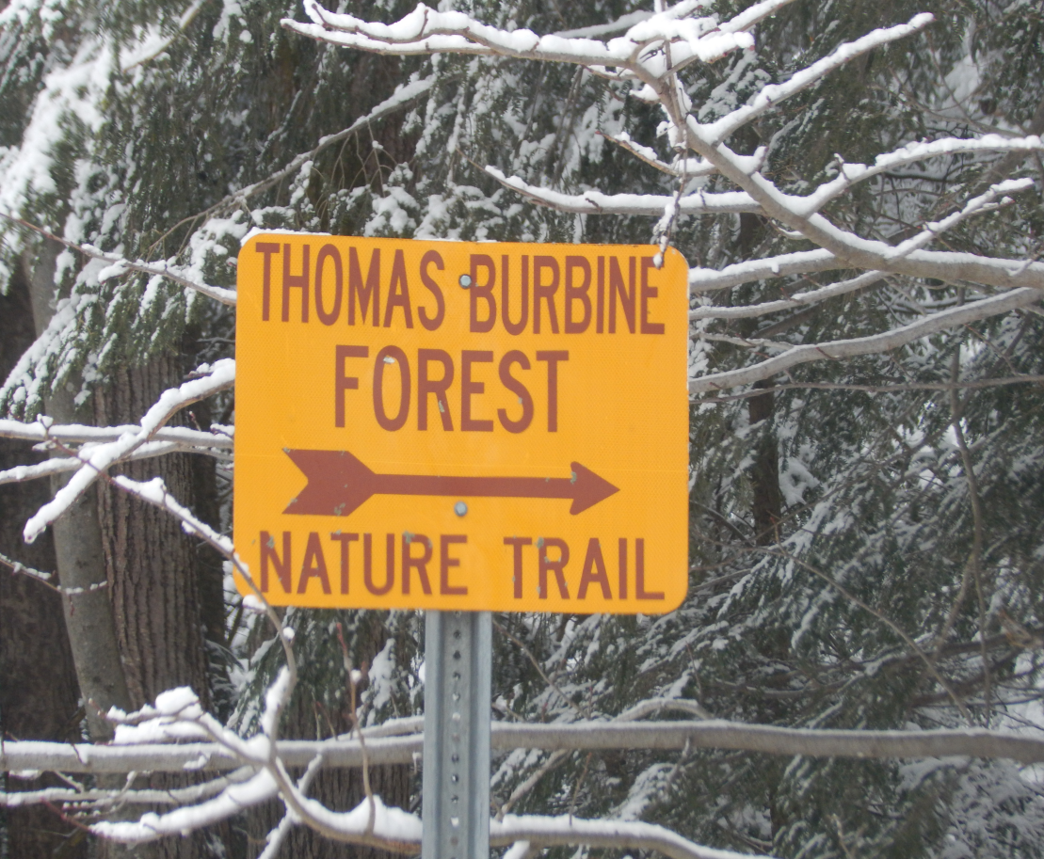

The Charleston Historical Society was founded in 1978 by Edythe J. Meserand and is located in the old Baptist Church on Polin Road, just off State Rt 30A.
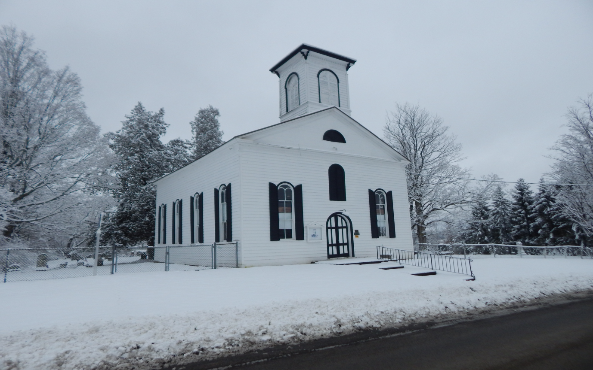

Town of Charleston Municipal Building
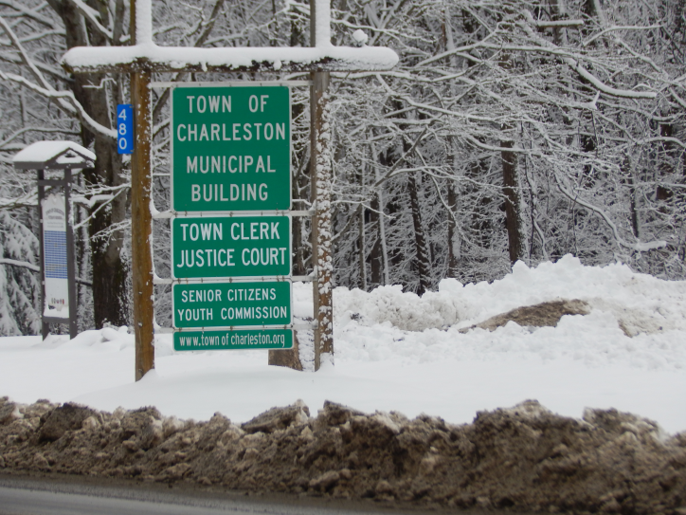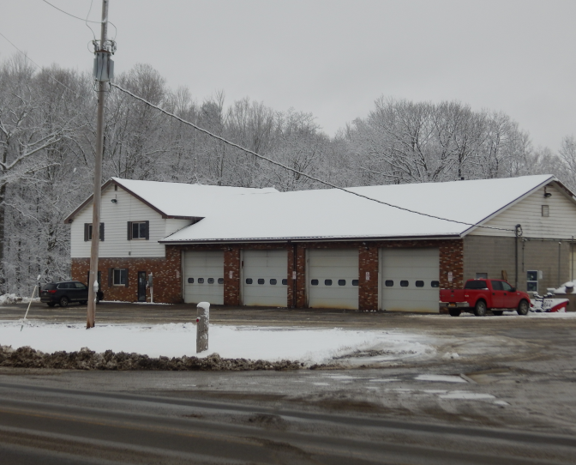

Town of Charleston Fire Department and EMS facility
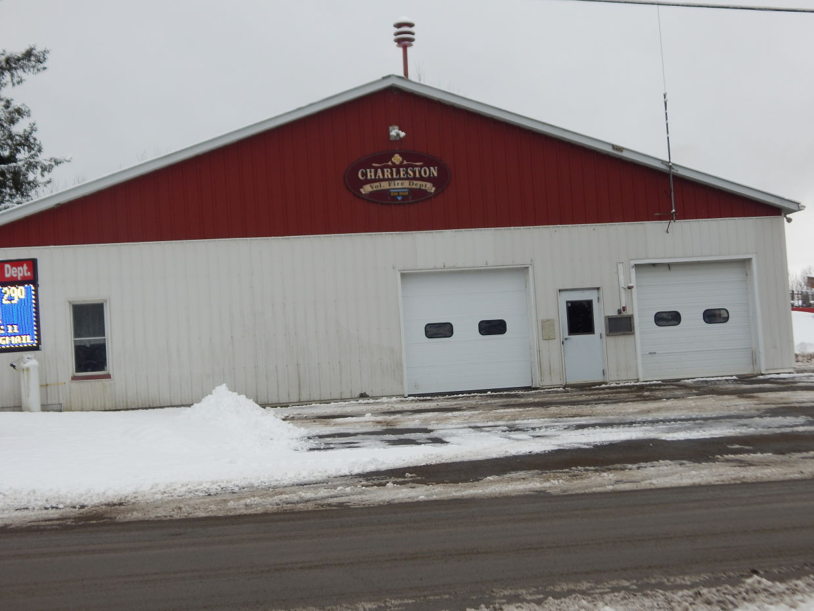

Town of Charleston newly constructed Road Salt/Dirt storage facility.
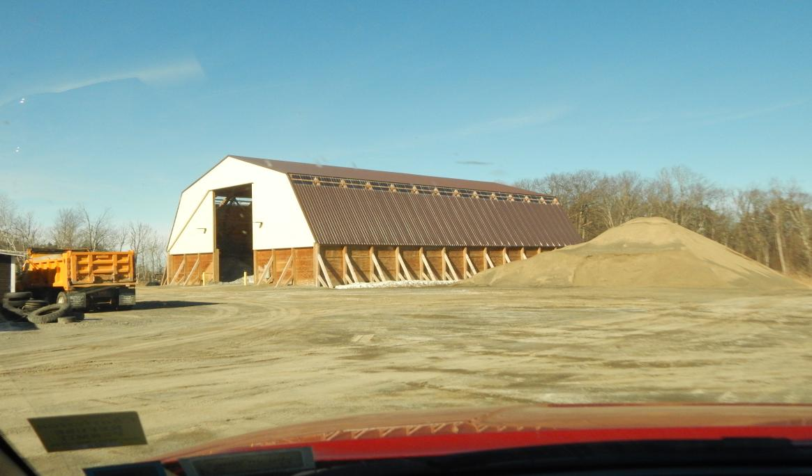

Town of Charleston Fire House at Burtonsville

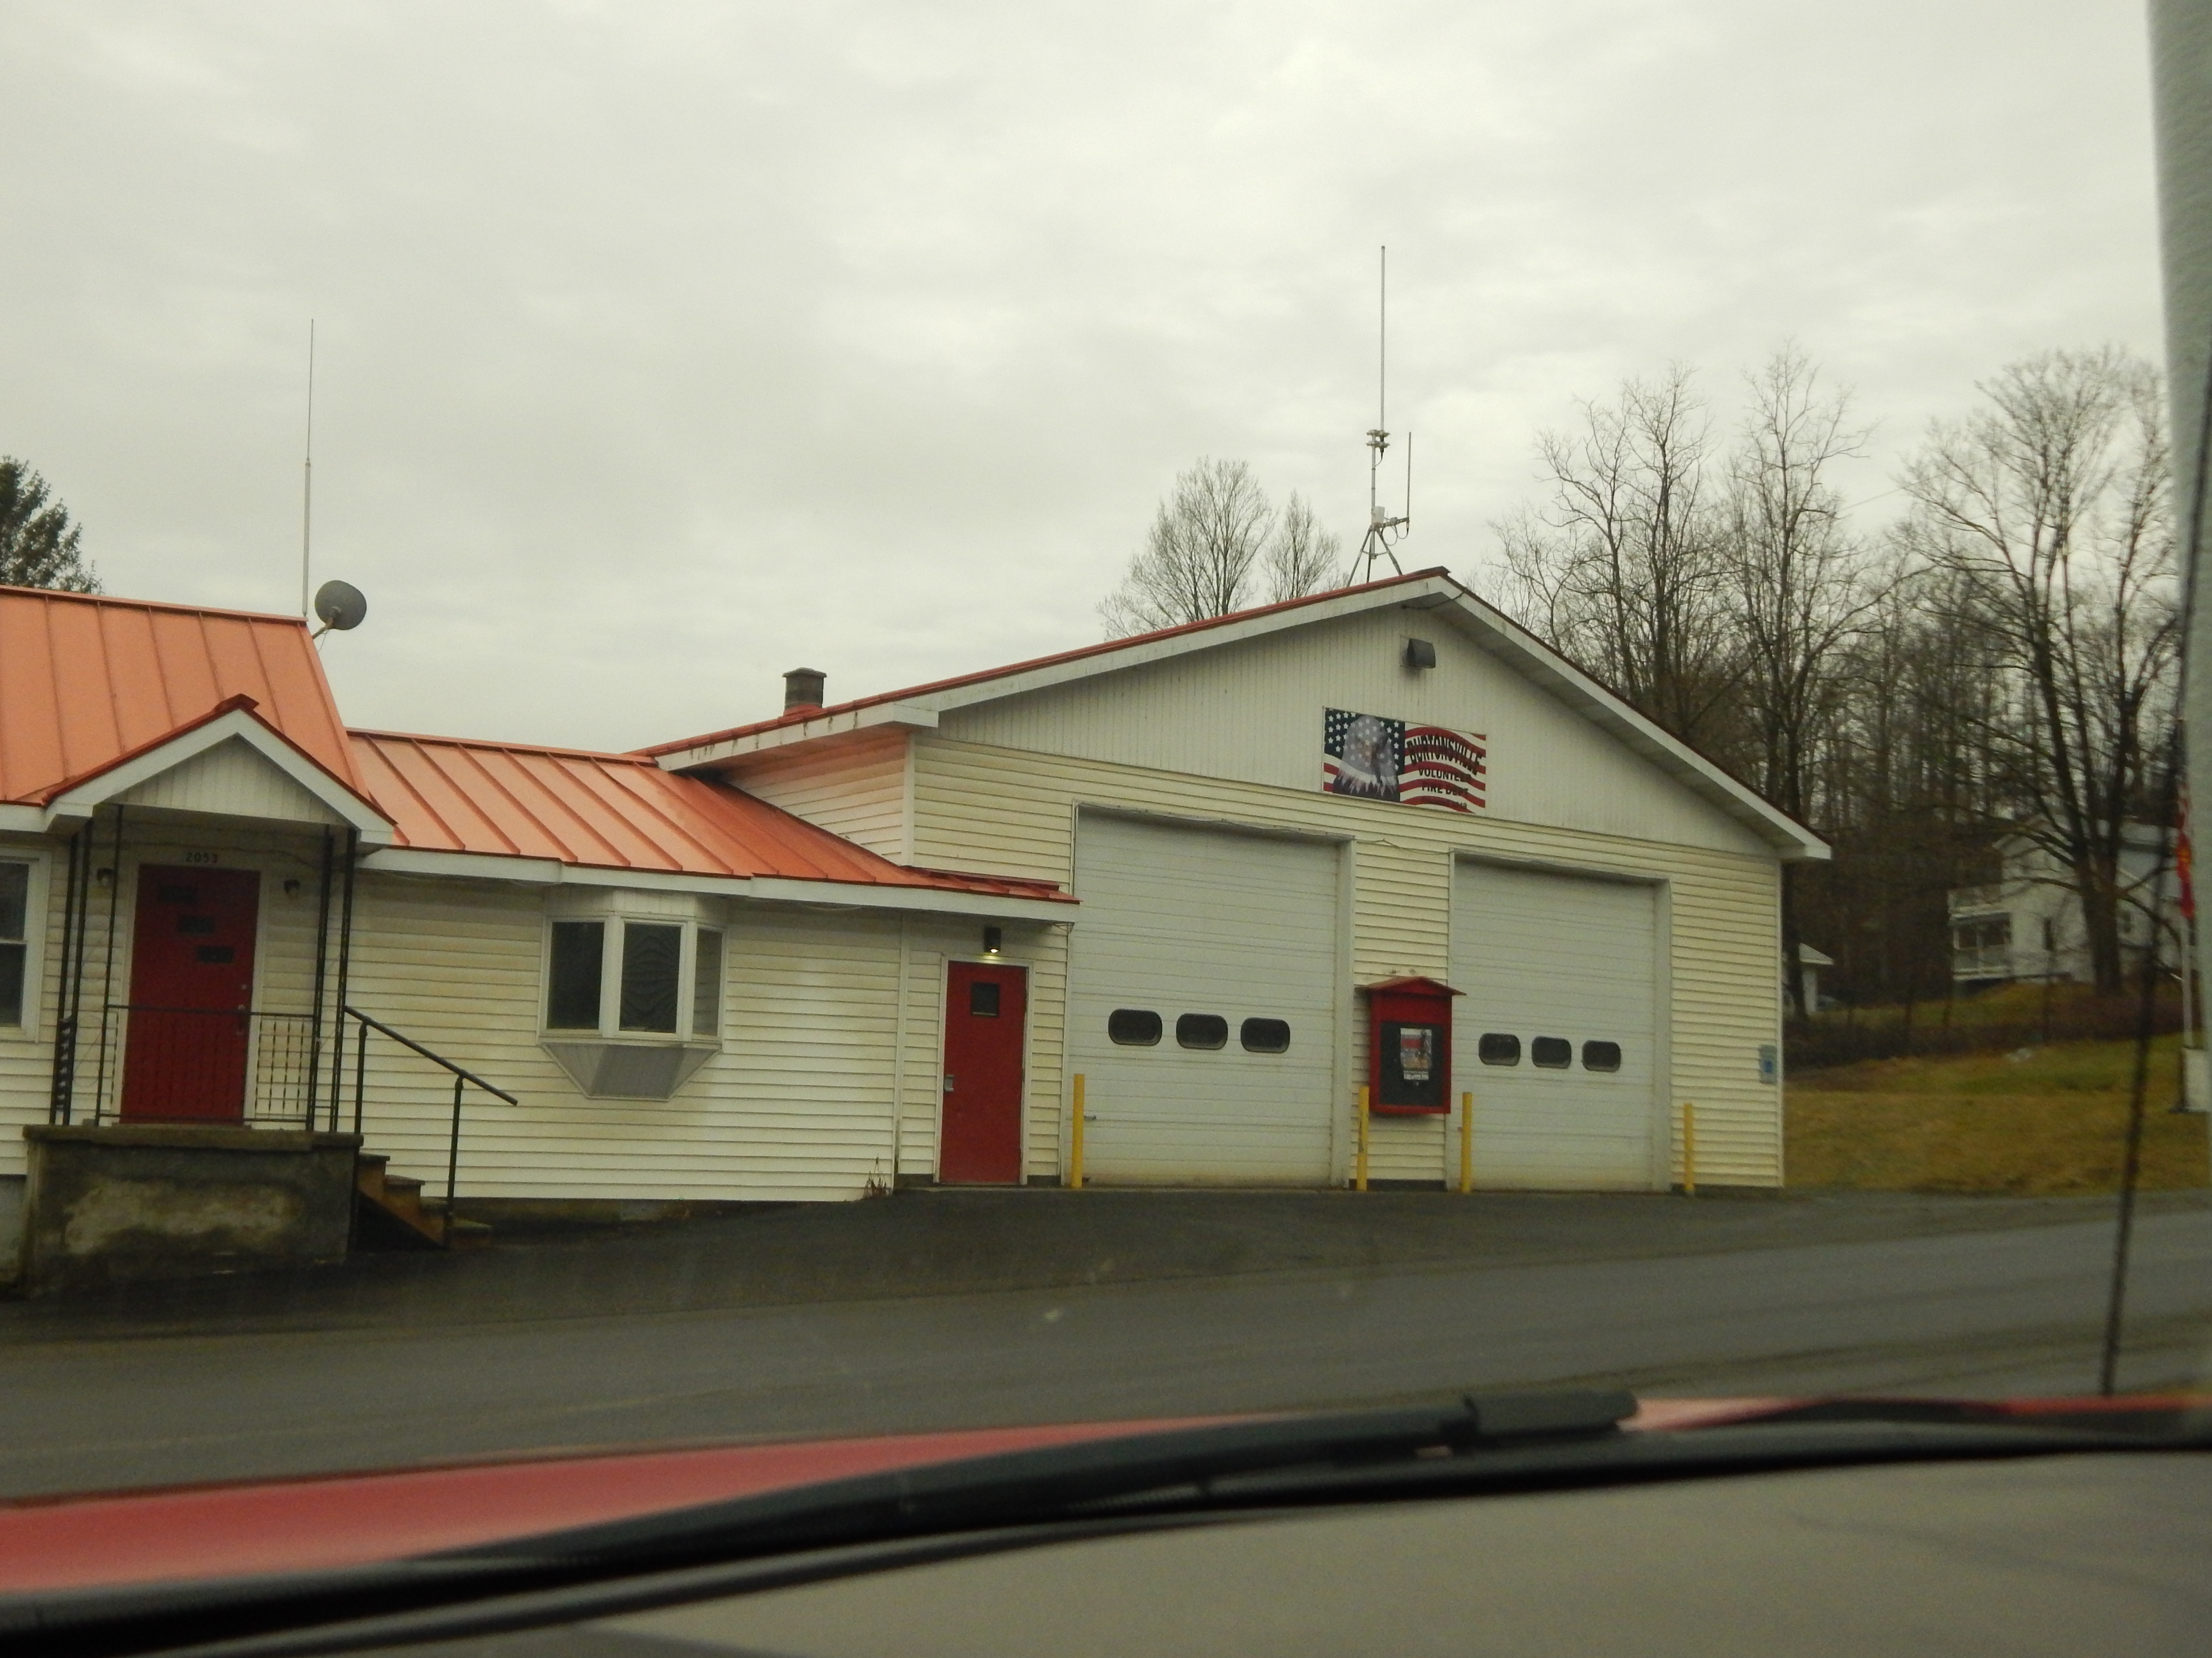

Town of Charleston Historical Signs
