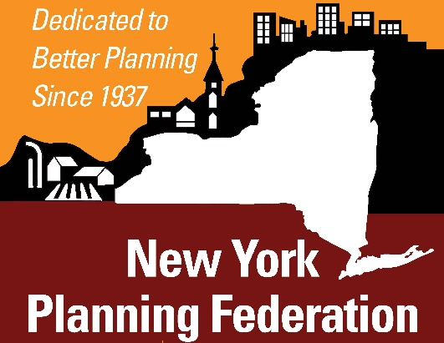
FOR IMMEDIATE RELEASE Contact: Barbara Samel, Executive Director
Phone: 518-512-5270
Email: bsamel@nypf.org
Website: www.nypf.org

James W. Ely, Jr. Awarded New York Planning Federation’s

John O. Cross Award for Planning Board Chair

Each year, the New York Planning Federation (NYPF) celebrates outstanding achievements and excellence in the fields of planning, zoning and land use practice in New York State. Awards are normally presented at the NYPF Annual Conference. This year, the awards are being presented virtually. The John O. Cross Award is named in honor of the former chair of the Town of Chili Planning Board. It is given each year to an outstanding Planning Board Chair. This year’s recipient is James W. Ely, Jr., Chair of the Town of South Bristol Planning Board. The award was presented on Wednesday, June 9.
Jim has been Chair of the Planning Board for nine years. He retired from a long and illustrious career as an attorney and law professor at Vanderbilt University Law School with expertise in real estate law, and in particular, property rights, and he has applied his professional expertise as a volunteer and as Chair of the South Bristol Planning Board. He is a tireless member and chairperson of the Planning Board, present at every session, and making sure that everyone is heard at meetings. He has gained the respect and admiration of his fellow board members, applicants, colleagues at Town Hall, and the Town’s citizens. His professional demeanor and the efficient way he facilitates meetings makes Jim a valuable asset to the community. Jim is also well versed in municipal law and planning board procedures, and his dedication has helped preserve and protect the Town’s natural resources and character. In addition to being a strong leader of the Planning Board, Jim has participated and applied his expertise in a number of municipal initiatives adopted by the Town of South Bristol, including a stream protection law, a short-term rental law, regulations for large-scale solar energy systems, and the Town’s Comprehensive Plan update.
The Town of South Bristol residents have greatly benefitted from his service as Chair of the Planning Board. Mr. Ely is a steadfast, fair and patient public servant who truly puts his community first.
NEW YORK PLANNING FEDERATION is a non-profit membership organization established in 1937. Our mission is to promote sound planning and zoning practice throughout New York State. Membership, which currently includes nearly 10,000 individuals, is open to anyone supporting this mission. Membership categories include municipalities, counties, public organizations, private businesses, individuals, and libraries.

