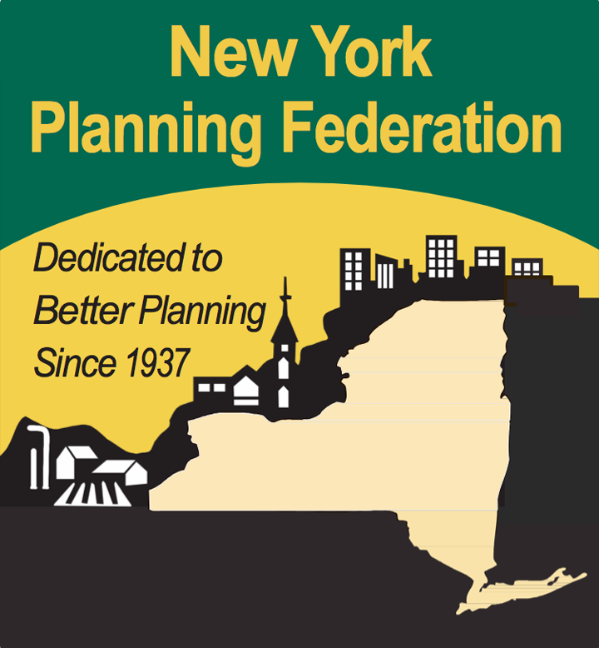Membership Application

Membership Type Member Name Contact Name Address
City / State / Zip

County

Phone / Fax

Email

Please mail or Fax to:
New York Planning Federation
600 Broadway, Albany, NY 12207
T: (518) 512-5270
F: (518) 512-5274
E: nypf@nypf.org
W: www.nypf.org
NYPF Board of Directors

President: Nina Peek, AICP

1st Vice President: Alison La Pointe, Esq.

2nd Vice President: Ed Jackson Immediate Past Pres: Tim Stalker Treasurer: Ken Swanekamp Region 1 & 2: Nzingha Milanes
Region 3: Jon Kanter, AICP

Elaine McClung Region 4: Charles A Voss, AICP Region 5 Andrea Smith, AICP Region 7: Jane Rice, AICP
Region 8: Vacant

Region 9: John Marriott

Directors at Large: Doug Finch

Robert Galvin, AICP
Mark Schachner, Esq
Donald Young, Esq
Patricia Tatich, AICP

Executive Director: Judith Breselor, AICP

NYPF is a statewide not-for-profit organization founded in 1937 to promote sound planning, land use and zoning practices in New York State. Our membership base helps NYPF foster orderly growth and sustainable development, balanced with the protection of vital natural resources.

Welcome to the best source for comprehensive, cost-effective education and training certification for those involved with planning at the local, re- gional and statewide levels. Join our collective network of partnerships, immense resources, forums, workshops, trainings and advocacy.

New York Planning Federation
600 Broadway, Suite 1
Albany, NY 12207
Tel: (518) 512-5270
Fax: (518) 512-5274
Email: nypf@nypf.org
Web: www.nypf.org

Benefits of Membership

Aside from access to our extensive resources and ac- tive network in the planning industry, NYPF members receive discounted rates on training, publications, and the annual conference. As a member, you’ll be kept
up-to-date with announcements, updates, and our monthly newsletter: “Planning News.”

NYPF’s website – ww w.n y p f.o rg – keeps members in- formed by offering current land use information rele- vant to every community across New York State. There’s a “members only” section on our website that provides training modules on SEQR, planning board and ZBA duties, site plan review, comprehensive plan- ning, and other essential topics. The NYPF website is another resource used to keep in touch with and pro- vide services for our members. All of the training op- portunities that NYPF offers, both in-person and online, can fulfill annual training requirements.

The NYPF Annual Conference, one of the premier training programs in the state, offers certification cred- it to planning board and ZBA members, code enforce-
ment officers, planners and attorneys. With in-depth sessions on both basic and advanced topics. Presenters | Municipal Population  Less than 10,000 | Annual Dues  $260.00
discuss relevant issues sustainability, design standards, | 10,000 – 19,999 | $285.00
ization, case law, ethics, and much more. The confer- | 20,000 – 49,999 | $310.00
ence is also a place for attendees to exchange ideas | 50,000 – 99,999 | $360.00
and information with their peers from communities | 100,000 – 199,999 | $435.00
and organizations across the state. | 200,000 + | $485.00

Who Should Become a Member?

⇒ Municipalities and counties including planning and zoning boards, elected officials, consultants staff members and code enforcement officers.

⇒ Professional firms, businesses and consultants including planners, attorneys, developers and builders, engineers, architects, landscape archi- tects, and real estate professionals.

⇒ Economic development and planning agencies

⇒ Universities, education institutions, and librar- ies

⇒ Students

⇒ Non-profit organizations

⇒ Engaged citizens

What Is the Cost of Membership?

Municipal dues are assessed according to size of population, while other members pay a flat fee. Municipalities may supply NYPF with the names and addresses of up to 15 board members who will receive newsletters and other materials; each firm and non-profit organization may add up to five employee names to their account.

agriculture and resource protection, downtown revital-

Members are always welcome to call or e-mail our office to request assistance with topics of concern to their municipality. Examples of technical assistance include planning and zoning audits, preparation of RFPs, community outreach, facilitation of comprehen- sive plan workshops, and zoning code reviews.
Professional Firm $410.00
Individual/Non-Profit $110.00
Library $60.00

Students *FREE

2017 / 2018 Rates

